***Davis Data Science Club***

*Spring 2023*

*Sign Language Detection*

Now, that we have collected our images, we will split them in 80/20 for training and testing. So

1. Move 12 images & their respective XML files to the Train Folder (C:\Users\jenis\Desktop\SLD\RealTimeObjectDetection\Tensorflow\workspace\images\train)
2. Move the remaining 3 images & their respective XML files to Test Folder (C:\Users\jenis\Desktop\SLD\RealTimeObjectDetection\Tensorflow\workspace\images\test)

Note: Do this for every alphabet and you ***don’t*** have to make separate folders for each alphabet here; Let them get mixed in the Train and Test folder

**The next step in the project: Update Label Map**

1. Go to Jupyter Notebooks and open the Tutorial notebook (Tutorial.ipynb):

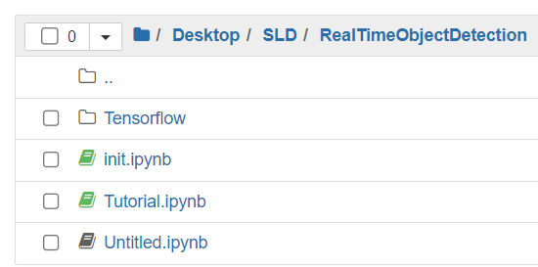

1. Run the first cell for “0. Setup Paths”
2. Go to the “1. Create Label Map” cell

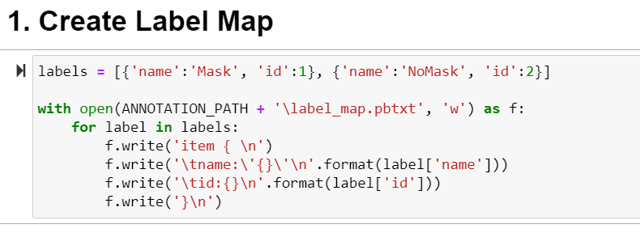

* 1. Update the Label array to your respective alphabets label names to ‘b’,’c’, ’d’, etc., and update the id numbers to 1,2,3,4,5 for the individual label names for your respective set of alphabets.

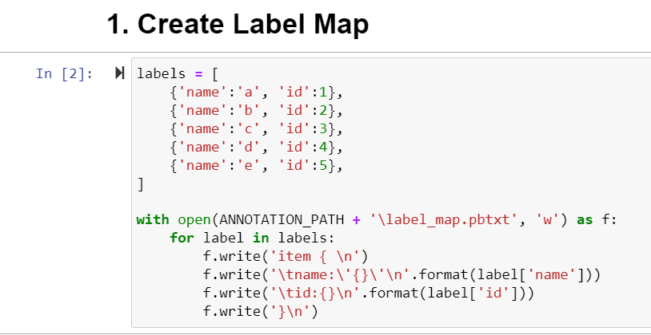

1. Run the “1. Create Label Map” cell

In your Workspace -> Annotations you should have a file called label_map (pbtxt file)

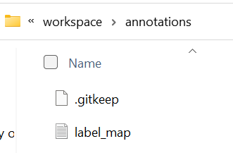

And when you open the label_map file, it should look like this

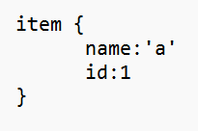 but you all should have 5 items there for your respective alphabets and their respective ids

**The next step in the project: Generate TFRecord**

Tfrecord is a special file format that Tensorflow Detection API uses. To simplify its generation we are using the script we got from the GitHub Repository in the beginning. Generate-tfrecord comes from the official TensorFlow detection tutorial, we’re going to leverage that.

We should have 2 additional files: Test and Train in the Workspace-> annotations folder so no changes are needed to the “2. Create TF Records” cell

<https://tensorflow-object-detection-api-tutorial.readthedocs.io/en/latest/install.html#set-env>

Follow the steps on this website to install the Tensorflow API.

I am also in the process of doing so but it takes time and I’m running into errors myself currently.